Software Architecture Document
Hospital Management System
A role-based clinical platform — React 18 SPA + Django 5 / DRF
Version 2.1 — Phase 2 (Architecture Completion & Full Implementation)
Course: Software Architecture
Architecture model: Kruchten 4+1 · Style: MVC + REST API
Phase 1 submission: 4 May 2026 · Phase 2 submission: 21 May 2026
Repository: https://github.com/alrawii2/hospital-managemen-systems-PHASE-2.git

Table of Contents
Table of Contents 1
Revision History 1
Team and Contributions 1
1. Introduction 1
1.1 Purpose 1
1.2 Scope and Two-Phase Development 1
1.3 System Selection: Purpose, Users, and Functionalities 1
1.4 Technology Platform 1
1.5 Architectural Representation: 4+1 and MVC 1
1.6 Definitions and Acronyms 1
2. Architectural Goals and Constraints 1
2.1 Quality Attributes 1
2.2 Security and Privacy 1
2.3 Constraints 1
3. Use Case View 1
3.1 Actors 1
3.2 Use Case Catalog 1
3.3 Use Case Diagram 1
3.4 Architecturally Significant Use Cases 1
3.5 Partial UI Code (View layer) 1
4. Logical View 1
4.1 MVC Layered Decomposition 1
4.2 Domain Model — Class Diagram 1
4.3 Entity Descriptions 1
4.4 REST API Layer 1
4.5 RBAC Permission Matrix 1
4.6 Partial Backend Code (Model layer) 1
5. Process View 1
5.1 Request Processing Pipeline 1
5.2 Sequence — Book Appointment 1
5.3 Activity — Appointment Lifecycle 1
5.4 Sequence — Prescription Workflow 1
5.5 Concurrency and Transactions 1
5.6 Code — Booking Controller 1
6. Development View 1
6.1 Component Diagram 1
6.2 Module Organization 1
6.3 Architecture-to-Implementation Traceability 1
6.4 Module Dependency Rules 1
6.5 Build Artifacts 1
7. Deployment View 1
7.1 Deployment Diagram 1
7.2 Runtime Nodes 1
7.3 Network Topology 1
7.4 Environment Configuration 1
7.5 Startup Sequence 1
7.6 Development vs Production 1
8. Algorithms and Code Foundations 1
8.1 Token-Based Authentication 1
8.2 Centralized RBAC Evaluation 1
8.3 Field-Level Encryption (Fernet) 1
8.4 Appointment Slot Generation 1
8.5 Double-Booking Prevention (Optimistic Concurrency) 1
8.6 Appointment Cancellation Guards (Phase 2.1) 1
8.7 Low-Stock Detection 1
8.8 Booking Calendar Rendering (Frontend) 1
8.9 Complexity Summary 1
9. Key Architectural Decisions (ADR) 1
10. Implementation Status and Rubric Mapping 1
10.1 Phase-by-Phase Step Log 1
10.2 Implementation Status 1
10.3 Rubric Compliance 1
11. References 1
Appendix A — Implementation Screenshots 1
A.1 Patient Portal 1
A.2 Doctor Workspace 1
A.3 Nurse Workspace 1
A.4 Administration 1
Appendix B — Running the System and Accessing Each Role 1
B.1 Prerequisites 1
B.2 One-Command Setup 1
B.3 The Two Login Surfaces 1
B.4 Demo Accounts 1
B.5 Stopping and Resetting 1

Revision History
Date | Version | Phase | Description | Author
2026-04-12 | 0.1 | 1 | Significant use cases & key requirements identified | Team
2026-04-20 | 0.3 | 1 | Initial deployment sketch; candidate architecture | Team
2026-05-01 | 0.6 | 1 | Design model + React frontend integration | Team
2026-05-04 | 1.0 | 1 | Use Case, Logical, Process views (Phase 1 submission) | Team
2026-05-14 | 1.2 | 2 | Development View: component diagram + traceability | Team
2026-05-18 | 1.3 | 2 | Deployment View: containerized topology | Team
2026-05-21 | 2.0 | 2 | All five 4+1 views complete; ADRs; algorithms | Team
2026-05-17 | 2.1 | 2 | Patient cancellation, doctor availability, Room model, expanded dataset | Team
2026-05-19 | 2.2 | 2 | Role-unified dashboards (inline React), booking calendar, 11 role REST endpoints, restored split-card login; implementation screenshots | Team

Team and Contributions
This document and the corresponding implementation were produced by a three-member team. Each member led one architectural concern across both phases and contributed to the SAD sections that document that concern.
Name | Student ID | Role | Primary contributions
Marwan Mohammed Taher Alkhatib | 220911700 | Backend / Domain Engineer | Domain model (15 entities), centralized RBAC matrix, REST API controllers, field-level encryption, slot-generation and booking-conflict algorithms, production settings. Authored §4 Logical View, §8 Algorithms.
Anas Ravioglu | 2309015858 | Frontend / Integration Engineer | React 18 SPA, role-aware dashboards, booking calendar, token-auth integration, Docker frontend image and Nginx reverse proxy. Authored §3.5 UI code, §6 Development View, §7.1 frontend topology.
Saleem Yahya Ahmad Almadfaie | 210911095 | Documentation Engineer | SAD compilation across both phases, all UML/PlantUML diagrams, traceability matrices, ADR record, rubric mapping and cross-view consistency. Authored §1 Introduction, §5 Process View, §9–§10.

1. Introduction

This document is about the Hospital Management System. The Hospital Management System is a web application. It does a lot of things. The Hospital Management System manages registration. The Hospital Management System also manages doctor scheduling. The Hospital Management System handles appointment booking and cancellation. The Hospital Management System keeps track of records. The Hospital Management System stores prescriptions. The Hospital Management System also manages pharmacy inventory. The Hospital Management System keeps track of equipment. The Hospital Management System handles room allocation. The Hospital Management System also has dashboards.

The document, about the Hospital Management System follows a model. This model is called Kruchtens 4+1 view model. The Hospital Management System was. Implemented in two phases. These phases were iterative.

1.1 Purpose

The SAD reveals what the important architectural choices in the system are. The SAD has three target audiences: those grading whether or not the implementation corresponds to the architecture as written, new people coming into the project and learning the code, and the project members themselves.

1.2 Scope and Two-Phase Development
HMS was built in two graded iterations, as the course requires:
- Phase 1 (delivered 4 May 2026): system selection and the first three 4+1 views — Use Case, Logical, and Process — together with an initial working implementation of the backend domain model, REST API, and a React frontend covering the patient workflows.
- Phase 2 (delivered 21 May 2026): completion of the remaining two views — Development and Deployment — a production-ready containerized deployment, and a feature expansion (Phase 2.1) that added patient-initiated cancellation, doctor weekly availability with dynamic slot generation, a Room entity, and a full demonstration dataset.
The present version (2.1) reflects the complete system: six roles, fifteen domain entities, eighteen use cases, and all five 4+1 views.

1.3 System Selection: Purpose, Users, and Functionalities
Target system. HMS is an internal hospital platform that unifies clinical, pharmacy, and administrative workflows behind a single role-aware web interface, replacing paper schedules and spreadsheet inventories with an auditable, access-controlled application.
Users (six roles).
- Patient — registers, logs in, browses doctors, books and cancels appointments, and tracks their own visit history.
- Doctor — views their daily schedule, manages a weekly availability calendar, writes medical records, and prescribes medication.
- Nurse — has department-scoped read access to prescriptions, drug stock, and equipment.
- Pharmacist — owns the hospital-wide drug catalog and per-department stock.
- Management — reads operational KPIs (low stock, equipment status, appointment volume) with no access to protected health information.
- Admin — manages users, profiles, and departments through the Django admin.
Core functionalities. Authentication and registration; doctor discovery; availability-driven appointment booking with conflict prevention; cancellation; clinical documentation (records and prescriptions); pharmacy catalog and inventory management; equipment and room tracking; and read-only operational dashboards.

1.4 Technology Platform
Concern | Technology
Frontend (View) | React 18 single-page application, built with Vite; hand-authored CSS design system
Backend (Controller + Model) | Django 5.2 on Python 3.12, Django REST Framework 3.15
API style | RESTful JSON over HTTP; token authentication (rest_framework.authtoken)
Database | SQLite 3 for local development; PostgreSQL 15 in production
Cache / throttling | Redis 7 (DRF rate limiting, cache backend)
Field encryption | django-encrypted-model-fields (Fernet, AES-128-CBC + HMAC)
App server | Gunicorn 21 (4 sync workers) behind Nginx 1.25
Packaging | Docker + Docker Compose (db, redis, backend, frontend/nginx)

1.5 Architectural Representation: 4+1 and MVC
The architecture is documented with Kruchten's 4+1 view model and realized in the Model–View–Controller pattern extended with a REST API bridge. The two framings are complementary: 4+1 organizes the documentation into five viewpoints, while MVC describes how responsibilities are split inside the running system.
4+1 View | SAD section | What it captures
Use Case | §3 | Actors and the 18 use cases that motivate the architecture
Logical | §4 | Domain model (15 entities), MVC layers, REST API, RBAC matrix
Process | §5 | Runtime request flows, concurrency, transactions
Development | §6 | Module/component decomposition and code organization
Deployment | §7 | Containerized production topology and environment
MVC mapping. The View is the React SPA; the Controller is the pair of Django layers that handle requests (template controllers in views.py and REST controllers in api_views.py, with serializers.py marshalling JSON); the Model is the Django ORM domain layer in models.py. A centralized RBAC module (permissions.py) is the cross-cutting authority that every controller consults.

1.6 Definitions and Acronyms
Term | Meaning
SAD | Software Architecture Document
MVC | Model–View–Controller architectural pattern
RBAC | Role-Based Access Control
DRF | Django REST Framework
SPA | Single-Page Application
PHI | Protected Health Information
ORM | Object–Relational Mapping
ADR | Architecture Decision Record
Fernet | Symmetric authenticated-encryption scheme (AES-128-CBC + HMAC-SHA256)

2. Architectural Goals and Constraints

2.1 Quality Attributes

Security: The system contains PHI data, so security considerations, such as confidentiality and least privilege, take precedence, and include things like token-based authentication, RBAC, and field encryption.

Reliability: There must be no possibility of booking the same doctor twice. This requirement is enforced within the database, not just the application itself, such that two simultaneous requests cannot both succeed.

Maintainability: Permission checks all live in one class, making it easy to find all the permissions listed in the documented permission matrix.

Portability: Using the same image in development and production, all configuration parameters are passed through the environment variables, while switching between an SQLite database in development and a PostgreSQL database in production is done solely via configuration.

2.2 Security and Privacy

• Authentication: token generation on the server side; the React client stores the token in memory and attaches it to all authenticated requests using Authorization: Token header.

• Authorization: six roles checked via a single matrix (§4.5); row-specific checks (ownership, department membership) complement role checks.

• Confidentiality at rest: User.phone and Patient.address fields are encrypted with Fernet; in the production setup, the database doesn’t expose its host port and can be accessed only via the Docker network.

• Rate limiting: DRF limits anonymous traffic (30/min) and authenticated traffic (120/min). 2.3 Constraints

• Constraint for the course: a layered architecture (MVC, REST, SOA, microservices) should be used; HMS implements MVC and REST.

• Constraint for the team: up to three members; the scope was chosen with an aim to be implemented and shown by a team of three in two parts.

• Constraint for deployment: the system needs to be deployable and working; using a Docker Compose setup meets that requirement.

3. Use Case View
The Use Case View captures system functionality from the actor's perspective. It is the view that drives the others: each use case is realized by a controller, persisted by the model, and exercised by a runtime flow in the Process View.

3.1 Actors
- Patient, Doctor, Nurse, Pharmacist, Management, Admin — the six roles defined on the User entity. Role is the single attribute that the entire permission matrix keys on.

3.2 Use Case Catalog
Eighteen use cases span the six actors. UC-1 through UC-16 were defined in Phase 1; UC-17 and UC-18 were added in Phase 2.1.
Actor | Use cases
Patient | UC-1 Register, UC-2 Log in, UC-3 Browse doctors, UC-4 Book appointment, UC-5 View my appointments, UC-17 Cancel my appointment
Doctor | UC-2 Log in, UC-6 View daily schedule, UC-7 Add medical record, UC-8 Prescribe medication, UC-12 View drug stock, UC-13 View equipment, UC-18 Manage my availability
Nurse | UC-2 Log in, UC-9 View department prescriptions, UC-12 View drug stock, UC-13 View equipment
Pharmacist | UC-2 Log in, UC-10 Manage drug catalog, UC-11 Adjust drug stock, UC-12 View drug stock
Management | UC-2 Log in, UC-12 View drug stock, UC-13 View equipment, UC-14 Update equipment status, UC-15 View KPI dashboard
Admin | UC-1 Register (on behalf), UC-2 Log in, UC-16 Manage users, profiles, departments
Two «include» relationships are significant: UC-4 (Book) includes UC-2 (Log in) — booking requires an authenticated session — and UC-7 (Add medical record) includes UC-8 (Prescribe), because prescriptions are written against a record the doctor authored.

3.3 Use Case Diagram
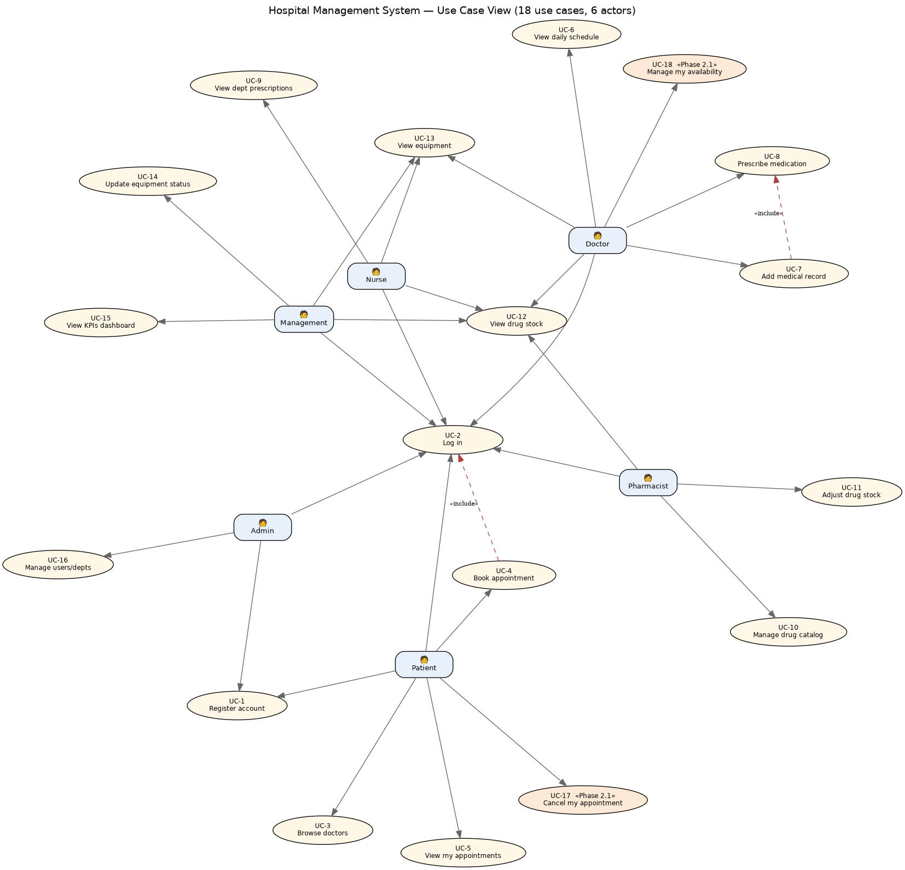
Figure 1 — Use Case Diagram. Six actors and eighteen use cases; UC-17 and UC-18 (shaded) are the Phase 2.1 additions.

3.4 Architecturally Significant Use Cases

• UC-4 Book appointment is the most significant use case as it implements token-based authentication, role validation, availability-based slot validation, atomic database writes constrained by uniqueness constraints, JSON marshaling, and React state updates. It is described in terms of a procedure in §5.2 and an algorithm in §8.4-§8.5.

• UC-18 Manage availability is significant since it acts as input to UC-4: the available slots for booking by the patient are derived from the doctor’s availability slots (§8.4).

• UC-17 Cancel appointment exhibits owner-based authorization checks and state-transition validations (§8.6).

3.5 Partial UI Code (View layer)
Patient workflows are realized in the React SPA. The shared apiFetch helper attaches the auth token to every request; LoginPage posts credentials and lifts the returned user and token into application state, which then selects the role-appropriate dashboard.
JavaScript / React
// Frontend/hospital-frontend/src/App.jsx — View layer (UC-2 Log in)
const API = "http://localhost:8000";

async function apiFetch(path, options = {}, token = null) {
const headers = { "Content-Type": "application/json" };
if (token) headers["Authorization"] = `Token ${token}`;
const res = await fetch(`${API}${path}`, { ...options, headers });
const data = await res.json();
if (!res.ok) throw new Error(data.error || "Request failed");
return data;
}

function LoginPage({ onLogin }) {
const [form, setForm] = useState({ username: "", password: "" });
async function handleSubmit(e) {
e.preventDefault();
const data = await apiFetch("/api/login/", {
method: "POST", body: JSON.stringify(form),
});
onLogin(data.user, data.token); // backend returns user.role -> app routes by role
}
/* ...split-card layout omitted... */
}
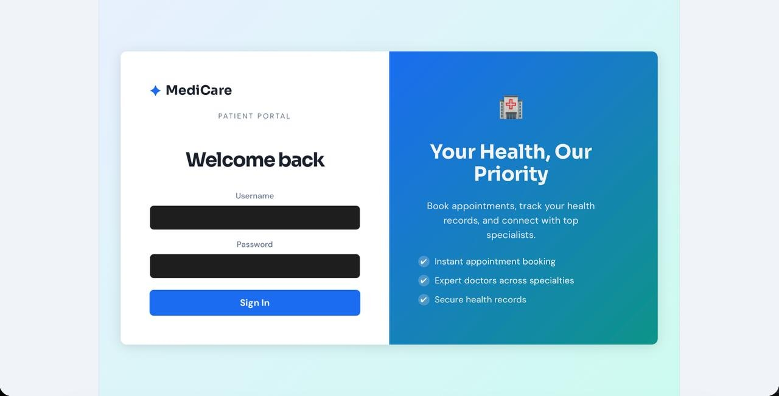
Figure 1a — Login screen (UC-1/UC-2). A single split-card form serves every role; the backend returns the user's role and the SPA routes to the matching dashboard.
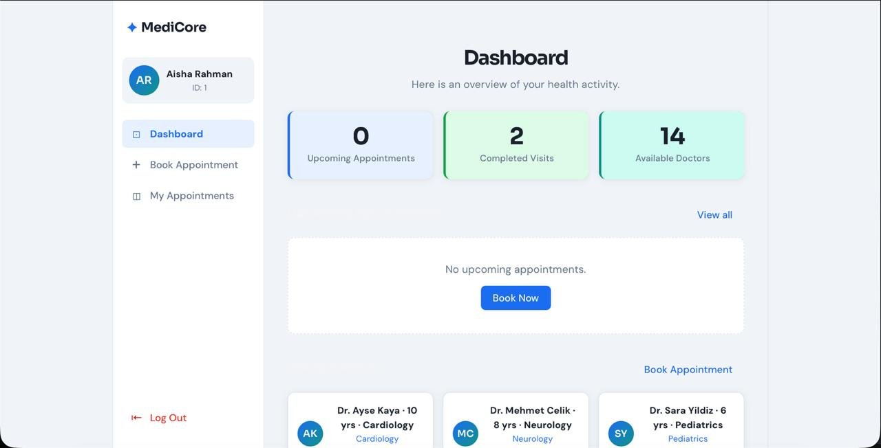
Figure 1b — Patient Dashboard. Stat cards (upcoming appointments, completed visits, available doctors) and the specialist directory.
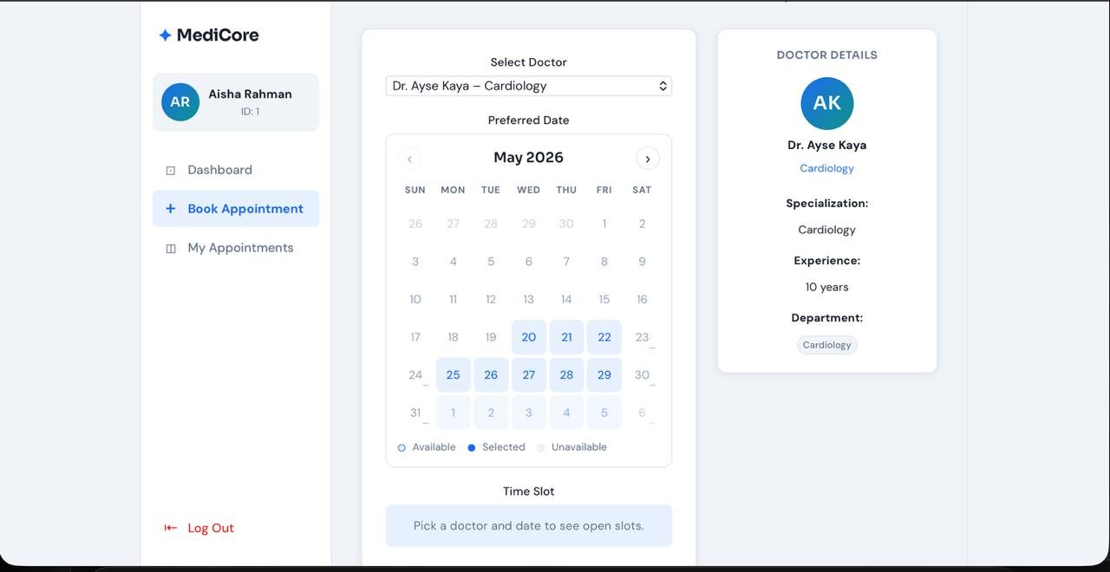
Figure 1c — Book Appointment (UC-4) with the Phase 2.2 availability calendar. Bookable dates are clickable; days outside the doctor's active weekly windows are disabled (Available / Selected / Unavailable legend).
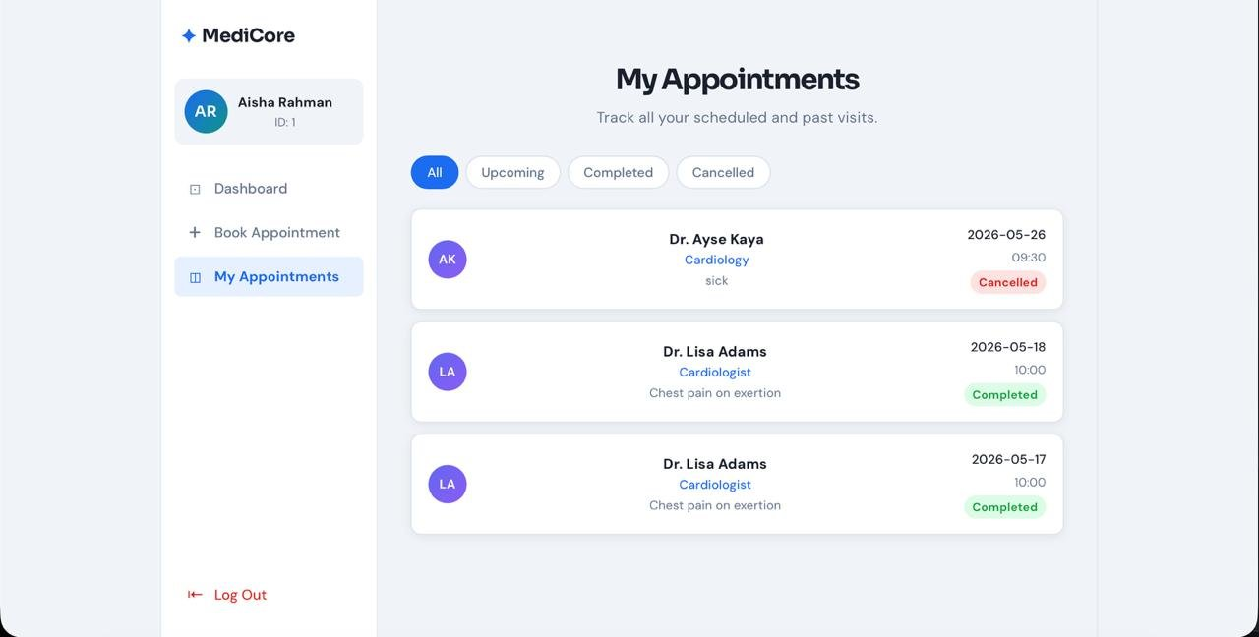
Figure 1d — My Appointments (UC-5/UC-17). All / Upcoming / Completed / Cancelled filters; a cancelled appointment is shown alongside completed visits.

4. Logical View
The Logical View describes the static structure of the system: the MVC layering, the domain model, the REST API surface, and the access-control matrix.

4.1 MVC Layered Decomposition
Layer | Technology | Responsibility | Files
View | React 18 + Vite | UI, component state, user interaction | Frontend/.../src/App.jsx, App.css
API bridge | Django REST Framework | JSON marshalling, token auth, throttling | accounts/api_views.py, serializers.py
Controller | Django views | Request handling, RBAC delegation, validation | accounts/views.py, forms.py
Model | Django ORM | Entities, constraints, encryption | accounts/models.py
Cross-cutting | Pure Python | Centralized RBAC matrix | accounts/permissions.py

4.2 Domain Model — Class Diagram
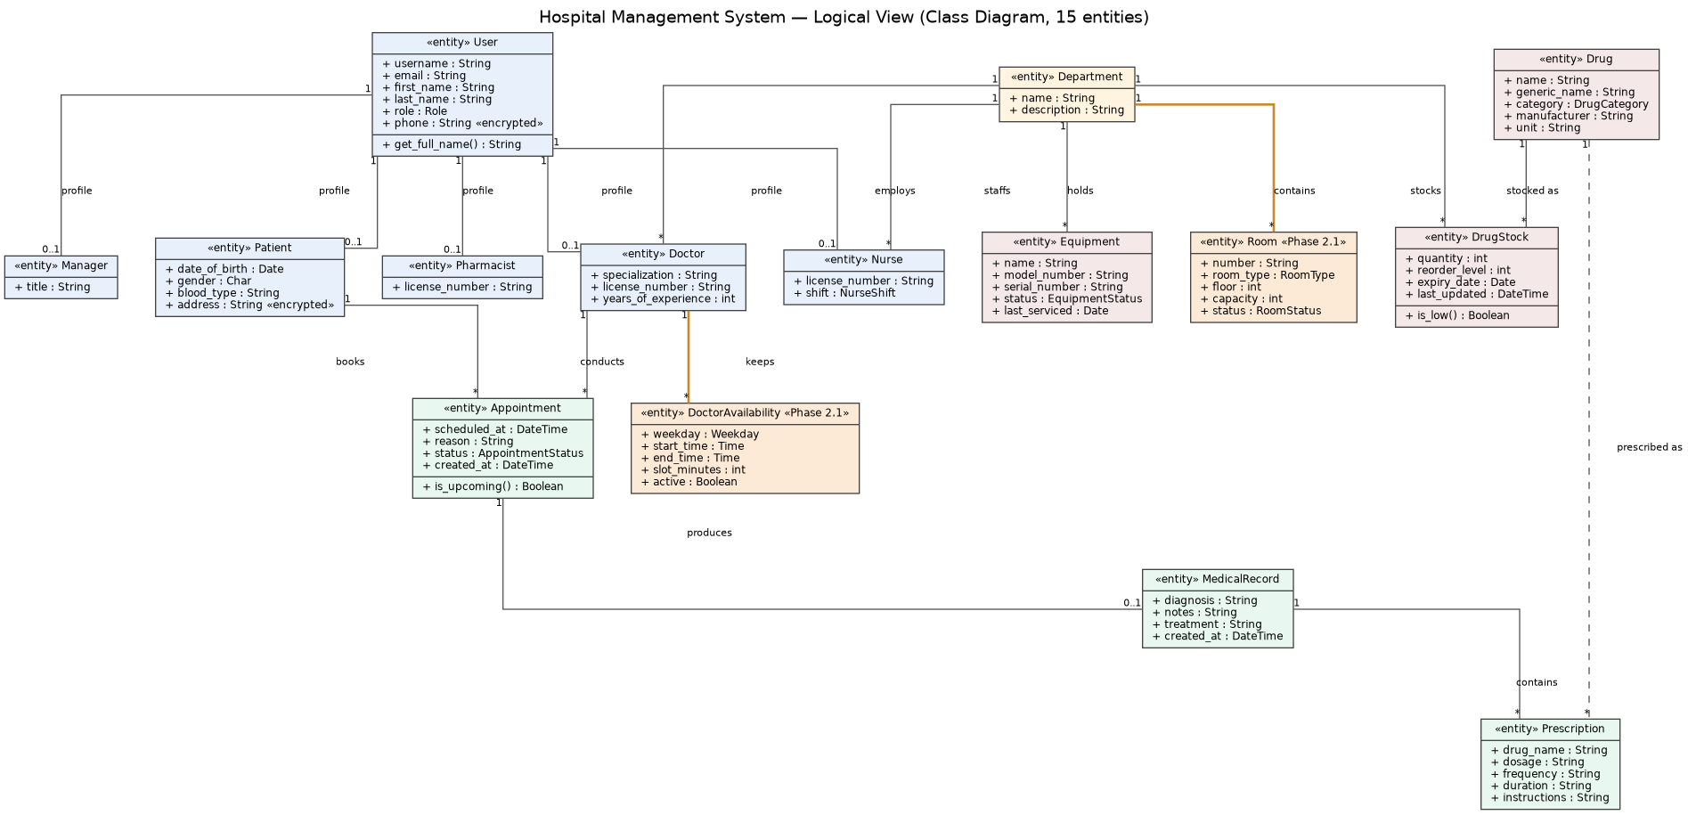
Figure 2 — Logical View class diagram. Fifteen entities; DoctorAvailability and Room (shaded) are the Phase 2.1 additions.

4.3 Entity Descriptions
- • User - Custom Django User object with role and phone encryption. Six 1-to-1 relationship objects are tied to it.
- • Patient/Doctor/Nurse/Pharmacist/Manager – role-specific profiles. Patient contains DOB, gender, blood type, and encrypted address. Doctor has additional specialization, license, years of experience. Nurse has additional shift. Pharmacist/Manager have license/title.
- • Department – clinical department; the domain within which nurses, doctors, inventory, equipment, and rooms function.
- • Appointment – an interaction between Patient and Doctor; has status (PENDING, CONFIRMED, COMPLETED/CANCELLED). Has a unique constraint defined on (doctor, scheduled_at).

• MedicalRecord - information, notes, and prescription for one appointment that has been attended (1:1).

• Prescription – medication line that is associated with MedicalRecord (1:N), optionally associated with a Drug.

• Drug – hospital-wide catalog of drugs (initiated from the WHO Model List of Essential Medicines).

• DrugStock – department-specific stock, unique per combination of drug and department, with a reordering quantity.

• Equipment – physical piece of equipment allocated to a department with operational status.

• DoctorAvailability «Phase 2.1» – weekly availability interval with weekday, start/end times, and time slot duration. Unique per doctor-weekday-start_time combination. Slot generation (§8.4).

• Room «Phase 2.1» – a department's room, having a type, floor, capacity, and status among others. Unique per (department_id, number).

4.4 REST API Layer
The React SPA talks exclusively to the REST API. Endpoints follow a uniform pattern: a DRF function view, an explicit permission class, a role/ownership check delegated to permissions.py, an ORM query using select_related to avoid N+1 access, and a serializer that shapes the JSON.
Endpoint | Method | Purpose | Auth
/api/health/ | GET | Liveness + DB probe (Docker healthcheck) | none
/api/login/ | POST | Authenticate; return token + user{role} | none
/api/register/ | POST | Register a PATIENT account | none
/api/logout/ | POST | Delete the caller's token | token
/api/doctors/ | GET | List doctors with department + experience | token
/api/appointments/ | GET | List the patient's own appointments | Patient
/api/appointments/book/<doctor_id>/ | POST | Book an appointment in an open slot | Patient
/api/appointments/<id>/cancel/ | POST | Cancel own future appointment (Phase 2.1) | Patient (owner)
/api/doctors/<id>/availability/ | GET/PUT | Read or replace a doctor's weekly availability (Phase 2.1) | Doctor (self)/Admin
/api/doctors/<id>/slots/?date=… | GET | Compute open slots for a date (Phase 2.1) | token
/api/me/schedule/ | GET | Doctor's own appointments (Phase 2.2) | Doctor
/api/appointments/<id>/record/ | POST | Create medical record for a visit (Phase 2.2) | Doctor (owner)
/api/records/<id>/prescribe/ | POST | Add a prescription to a record (Phase 2.2) | Doctor (owner)
/api/me/department/stock/ | GET | Department drug stock, read-only (Phase 2.2) | Doctor / Nurse
/api/me/department/prescriptions/ | GET | Department prescriptions, read-only (Phase 2.2) | Nurse
/api/me/department/equipment/ | GET | Department equipment, read-only (Phase 2.2) | Doctor / Nurse
/api/drugs/ · /api/stock/<id>/ | GET/POST · PATCH | Pharmacy catalog and stock adjustment (Phase 2.2) | Pharmacist / Admin
/api/management/kpis/ | GET | Aggregated operational KPIs (Phase 2.2) | Management / Admin

4.5 RBAC Permission Matrix
Every access decision is evaluated by a predicate in permissions.py. The matrix below is the authoritative specification; the code in that module must remain consistent with it (R = read, W = write, dept = department-scoped, own = owner only).
Resource / action | Patient | Doctor | Nurse | Pharm. | Mgmt | Admin
Log in | ✓ | ✓ | ✓ | ✓ | ✓ | ✓
Browse doctors | ✓ | — | — | — | — | ✓
Book appointment | ✓ | — | — | — | — | ✓
View own appointments | own | own | dept | — | — | ✓
Cancel appointment | own | — | — | — | — | ✓
Manage availability | — | self | — | — | — | ✓
Read MedicalRecord | — | own | dept R | — | — | ✓
Write MedicalRecord | — | own | — | — | — | ✓
Read Prescription | — | own | dept R | all R | — | ✓
Drug catalog | — | R | R | R/W | R | ✓
Drug stock | — | dept R | dept R | R/W | R | ✓
Equipment | — | dept R | dept R | — | R/W | ✓
KPI dashboard | — | — | — | — | ✓ | ✓

4.6 Partial Backend Code (Model layer)
The Model layer is plain Django ORM. The Appointment model below shows the double-booking constraint and the encrypted fields are visible on User; the Phase 2.1 DoctorAvailability model shows the availability window that the slot algorithm consumes.
Python / Django ORM
# accounts/models.py — Model layer (excerpts)
class User(AbstractUser):
ROLE_CHOICES = [('PATIENT','Patient'),('DOCTOR','Doctor'),('NURSE','Nurse'),
('PHARMACIST','Pharmacist'),('MANAGEMENT','Management'),('ADMIN','Admin')]
role = models.CharField(max_length=12, choices=ROLE_CHOICES)
phone = EncryptedCharField(max_length=20, blank=True) # Fernet at rest

class Appointment(models.Model):
patient = models.ForeignKey(Patient, on_delete=models.CASCADE, related_name='appointments')
doctor = models.ForeignKey(Doctor, on_delete=models.CASCADE, related_name='appointments')
scheduled_at = models.DateTimeField()
status = models.CharField(max_length=10, choices=STATUS_CHOICES, default='PENDING')
class Meta:
unique_together = ('doctor', 'scheduled_at') # DB-level anti-double-booking

class DoctorAvailability(models.Model): # Phase 2.1
doctor = models.ForeignKey(Doctor, on_delete=models.CASCADE, related_name='availabilities')
weekday = models.IntegerField(choices=WEEKDAYS) # 0=Mon … 6=Sun
start_time = models.TimeField()
end_time = models.TimeField()
slot_minutes = models.PositiveIntegerField(default=30)
active = models.BooleanField(default=True)
class Meta:
unique_together = ('doctor', 'weekday', 'start_time')
The serializer below shapes the doctor list consumed by the booking screen; SerializerMethodField composes the display name and surfaces years of experience and specialization.
Python / DRF
# accounts/serializers.py — API bridge
class DoctorSerializer(serializers.ModelSerializer):
name = serializers.SerializerMethodField()
department = DepartmentSerializer()
class Meta:
model = Doctor
fields = ["id", "name", "specialization", "years_of_experience", "department"]
def get_name(self, obj):
return "Dr. " + obj.user.get_full_name()

5. Process View
The Process View describes the system's behavior at runtime: how a request flows through the layers, how concurrent writes are made safe, and how the multi-actor clinical workflows unfold.

5.1 Request Processing Pipeline
Step | Component | Action
1 | React (browser) | User action triggers apiFetch with Authorization: Token header
2 | Django URL dispatcher | Routes /api/* to the matching DRF controller
3 | DRF TokenAuthentication | Resolves the token to a User; attaches request.user
4 | Controller (api_views.py) | Role/ownership check via permissions.py, then business logic
5 | ORM (models.py) | Reads/writes the database; constraints enforce invariants
6 | Serializer | Converts model instances to JSON
7 | React state | Stores JSON, re-renders the affected components

5.2 Sequence — Book Appointment
The booking sequence shows the full round-trip including the alternative flows: successful creation (201), a uniqueness conflict caught by the database (400), a role denial (403), and missing input (400).
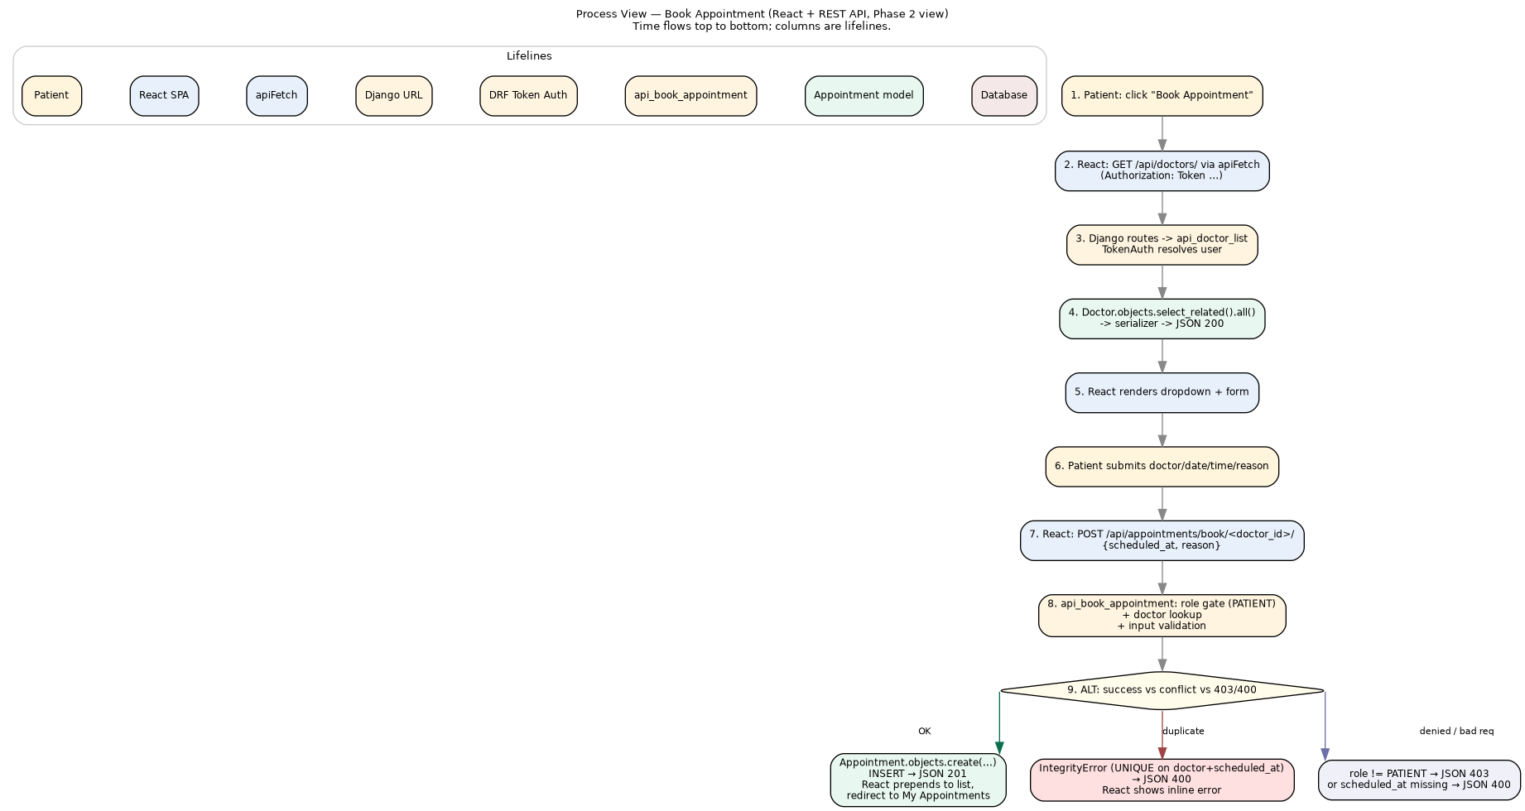
Figure 3 — Sequence: a patient books an appointment (React → DRF → ORM → DB), with success and error branches.

5.3 Activity — Appointment Lifecycle
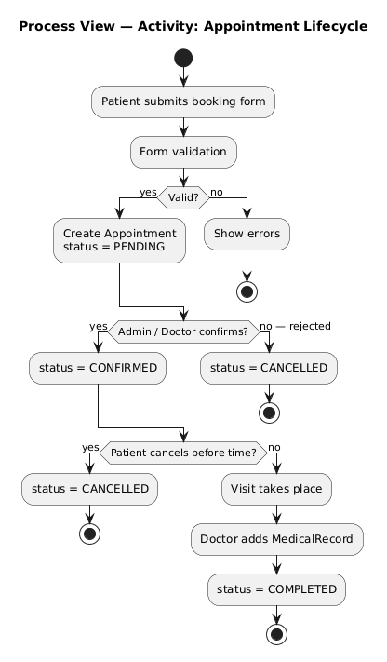
Figure 4 — Activity: the appointment state machine. PENDING → CONFIRMED → COMPLETED, with CANCELLED reachable from PENDING or CONFIRMED (UC-17).

5.4 Sequence — Prescription Workflow
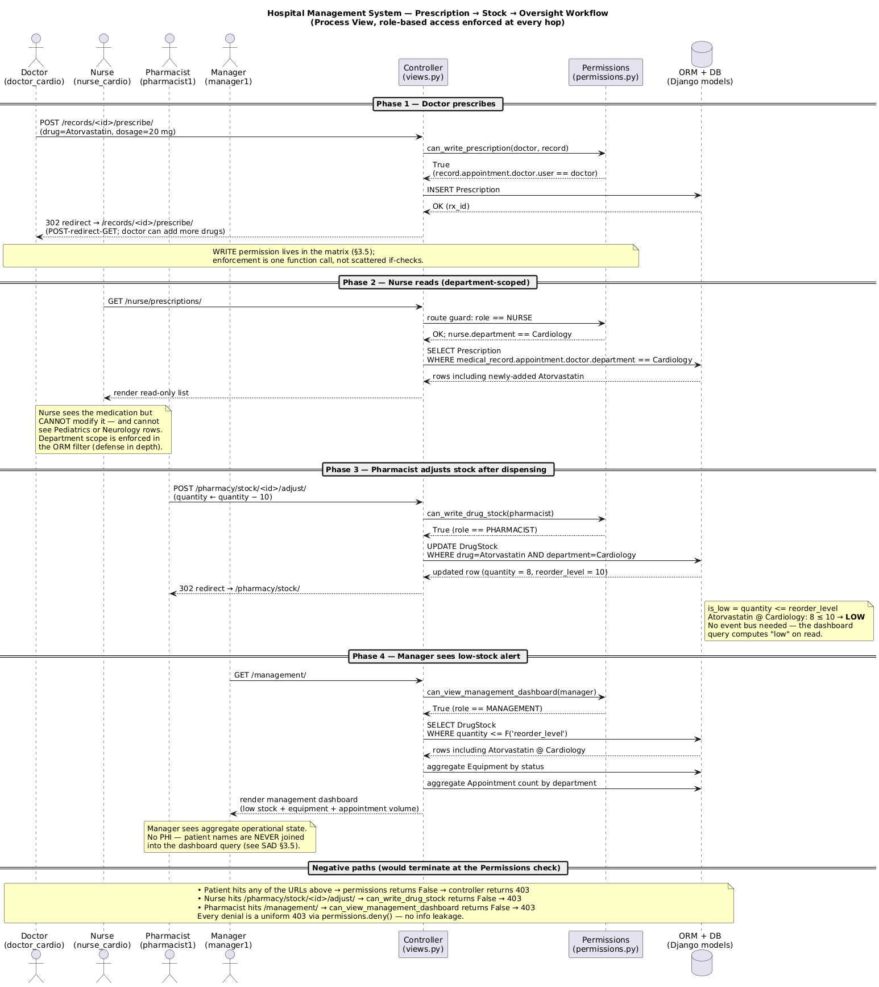
Figure 5 — Three-role prescription workflow. Each transition is gated by a single call into permissions.py rather than scattered inline checks.

5.5 Concurrency and Transactions

Phase 1 involved the development server with only one process, whereas, in production, Gunicorn is deployed with four worker processes, meaning that multiple concurrent requests are possible. Multiple levels of protection ensure the correctness of writing operations:

• Database integrity constraints — the unique_together('doctor','scheduled_at') field in Appointment and unique_together('drug','department') field in DrugStock prevent any competing writes at the database level, leading to an IntegrityError being caught by the app and returned in a proper 400 response.

• Transaction isolation – each controller is wrapped in Django request-level transactions ensuring partial completion of the write won't persist in the database.

• Query optimization – use of select_related allows combining multiple N+1 reads into one JOIN.5.6 Code — Booking Controller
The numbered comments correspond to the steps in Figure 3. Note that the role gate, doctor lookup, and input validation all run before the ORM create, and the create itself is wrapped in a try/except so the uniqueness constraint surfaces as a 400 rather than a 500.
Python / DRF
# accounts/api_views.py — Controller (UC-4)
@api_view(['POST'])
@permission_classes([IsAuthenticated])
def api_book_appointment(request, doctor_id):
if request.user.role != 'PATIENT': # 1. role gate
return Response({'error': 'Patients only.'}, status=403)
try:
doctor = Doctor.objects.get(pk=doctor_id) # 2. lookup
except Doctor.DoesNotExist:
return Response({'error': 'Doctor not found.'}, status=404)
scheduled_at = request.data.get('scheduled_at') # 3. validate
if not scheduled_at:
return Response({'error': 'scheduled_at is required.'}, status=400)
try: # 4. atomic create
appt = Appointment.objects.create(
patient=request.user.patient_profile, doctor=doctor,
scheduled_at=scheduled_at, reason=request.data.get('reason',''),
status='PENDING')
except Exception as e: # uniqueness -> 400
return Response({'error': str(e)}, status=400)
return Response(AppointmentSerializer(appt).data, status=201) # 5. serialize

6. Development View
The Development View describes the static organization of the source: the components, the modules that realize them, and the dependency rules that keep the layers clean.

6.1 Component Diagram
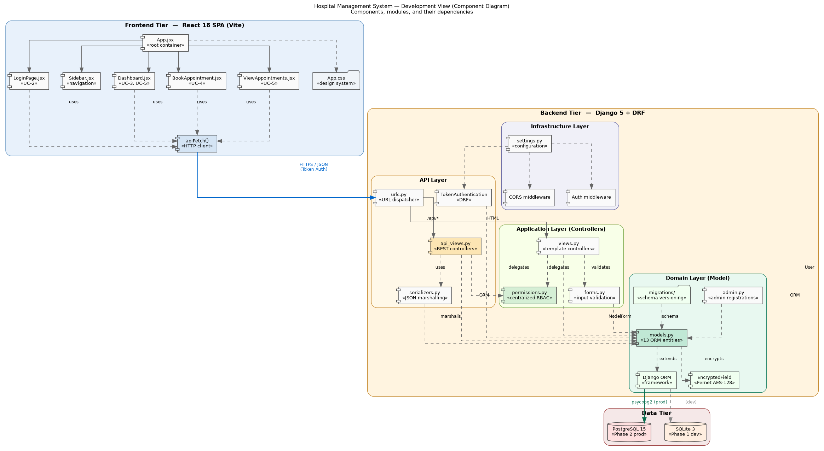
Figure 6 — Development View. Frontend tier, backend tier (API / Application / Domain / Infrastructure layers), and data tier with their dependencies.

6.2 Module Organization

• Frontend tier. Only one React SPA without a client-side router where the page state resides in App.jsx and a generic role sidebar that generates navigation based on roles. No UI library is used in the hand-crafted CSS design system to ensure that the package size remains lean and styling is clear.

• Backend tier. Four tiers: the API tier (controller + serializer + URL dispatchers), the app tier (template controllers, form controls, and the RBAC cross-cutting component), the domain tier (ORM models, admin registration, migrations, encrypted fields, seed command), and the infrastructure tier (settings, CORS, authentication middleware, WhiteNoise).

• Data tier. PostgreSQL for production and SQLite for development, both chosen exclusively based on environment settings.

6.3 Architecture-to-Implementation Traceability
Each box on the component diagram maps to a concrete file. This table is the proof that the documented architecture is the one that actually ships.
Architectural element | Realized in
View — React SPA | Frontend/hospital-frontend/src/App.jsx
View — design system | Frontend/hospital-frontend/src/App.css
API — REST controllers | accounts/api_views.py
API — JSON serializers | accounts/serializers.py
API — URL dispatcher | hospital_project/urls.py
Controller — template views | accounts/views.py
Controller — input validation | accounts/forms.py
Cross-cutting — RBAC matrix | accounts/permissions.py
Domain — 15 ORM entities | accounts/models.py
Domain — admin registrations | accounts/admin.py
Domain — schema migrations | accounts/migrations/
Domain — demo data seeder | accounts/management/commands/seed_data.py
Infrastructure — configuration | hospital_project/settings.py
Deployment — backend image | deployment/Dockerfile.backend
Deployment — frontend image | deployment/Dockerfile.frontend
Deployment — orchestration | deployment/docker-compose.yml
Deployment — reverse proxy | deployment/nginx.conf

6.4 Module Dependency Rules

• View → API bridge: permitted (only JSON via HTTPS). The front-end does not import any back-end code.

• Controller → RBAC matrix: mandatory. Every mutating controller uses permissions.py.

• Controller → Domain: permitted (no abstraction layer; ORM calls directly).

• RBAC → Domain: read-only. Permissions.py inspects but does not modify.

• Domain → anything else: prohibited. Models cannot import any other modules to keep migrations easy.

6.5 Build Artifacts
Artifact | Built from | Tool
React bundle (dist/) | src/ | Vite (npm run build)
Backend wheels | requirements.txt | pip (Docker builder stage)
Static collection | Django + DRF static | collectstatic via WhiteNoise
hms-backend image | Dockerfile.backend | docker compose
hms-frontend image | Dockerfile.frontend | docker compose

7. Deployment View
The Deployment View maps software onto runtime nodes. Phase 1 ran the dev servers on one workstation; Phase 2 packages the whole stack into Docker containers orchestrated by Docker Compose.

7.1 Deployment Diagram
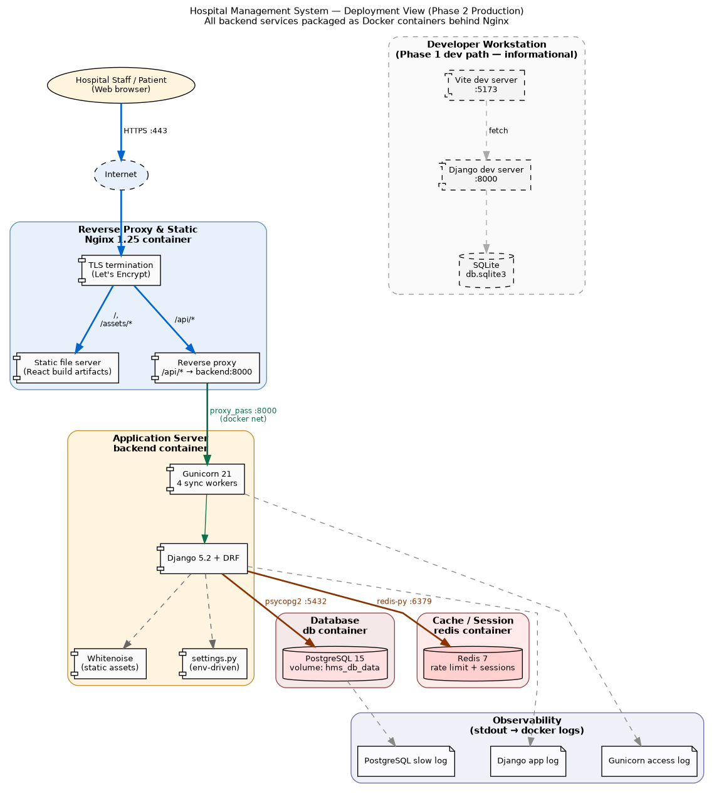
Figure 7 — Production topology. Four containers on one Docker network; only Nginx is published to the host.

7.2 Runtime Nodes
Container | Image | Purpose | Ports
frontend | Nginx 1.27 (alpine) | TLS, static React build, reverse-proxy /api/* and /admin/ | 80 (443 in prod)
backend | Python 3.12 + Gunicorn 21 | Django 5 + DRF; migrates on start; serves REST | internal :8000
db | postgres:15-alpine | Application database (volume hms_db_data) | internal :5432
redis | redis:7-alpine | Cache + DRF throttling | internal :6379

7.3 Network Topology

The four containers all run under one network interface created in Docker bridge mode. Only the port 80/443 of the frontend container is exposed. The remaining three backend/db/redis containers have no port exposed on the host and can be accessed only within the network.

7.4 Environment Configuration
Every environment-specific value is read from an environment variable, so the same image runs in dev, staging, and prod. Secrets are supplied through a .env file that is never committed.
Variable | Purpose
DJANGO_SECRET_KEY | Session/CSRF signing key
DJANGO_DEBUG | 0 in prod — enables all security headers
DJANGO_ALLOWED_HOSTS | Host header allow-list
FIELD_ENCRYPTION_KEY | Fernet key for encrypted columns
POSTGRES_* | Database name / user / password / host / port
REDIS_URL | Cache + throttle backend location

7.5 Startup Sequence

1. Postgres launches; its healthcheck determines when the backend begins serving requests.

2. Redis launches.

3. Backend waits for the db healthcheck, performs migrate and collectstatic operations.

4. Backend launches demo data seeding (one time only), then launches Gunicorn with 4 workers.

5. Nginx launches, serves React build files, and forwards requests to backend via proxy_pass at /api/* endpoints.

7.6 Development vs Production
Aspect | Development | Production
Frontend | Vite dev server :5173 (HMR) | Static build served by Nginx
Backend | manage.py runserver :8000 | Gunicorn behind Nginx
Database | SQLite file | PostgreSQL container (volume-backed)
CORS | allow-all | same-origin
Security headers | off (DEBUG) | HSTS, secure cookies, SSL redirect

8. Algorithms and Code Foundations
This section documents the non-trivial algorithms in the system and the foundations of how the code is organized to support them. It is the bridge between the architecture and the line-level implementation.

8.1 Token-Based Authentication
Approach. After login, authentication of credentials occurs in the backend and then a token is generated (or retrieved) from get_or_create and returned with the user's role information. The React application stores the token in memory only (never in local storage in order to reduce risk of XSS) with each request carrying an Authentication: Token header. Log out causes the server to delete the token making it invalid. Complexity: O(1).
Python / DRF
# accounts/api_views.py
@api_view(['POST']); @permission_classes([AllowAny])
def api_login(request):
user = authenticate(username=request.data.get('username'),
password=request.data.get('password'))
if not user:
return Response({'error': 'Invalid credentials'}, status=401)
token, _ = Token.objects.get_or_create(user=user)
return Response({'token': token.key,
'user': {'id': user.id, 'role': user.role,
'name': user.get_full_name() or user.username}})

8.2 Centralized RBAC Evaluation
Approach. Instead of sprinkling role checks throughout the controllers, all decisions are predicates in permissions.py that accept the user (and the object, for row-level decisions), and return a Boolean. Decisions are a combination of a role test and ownership/department membership test. The matrix documentation (§4.5) and code are tightly coupled, allowing a single deny() function to provide consistent 403s without any indication that a record exists. Complexity: O(1) per decision; department scope is a single integer comparison of a foreign-key id.
Python
# accounts/permissions.py — representative predicate
def can_view_drug_stock(user, stock):
if not user.is_authenticated:
return False
if user.is_superuser or user.role in ('ADMIN','PHARMACIST','MANAGEMENT'):
return True # hospital-wide
if user.role == 'DOCTOR':
doc = getattr(user, 'doctor_profile', None)
return doc is not None and stock.department_id == doc.department_id
if user.role == 'NURSE':
nurse = getattr(user, 'nurse_profile', None)
return nurse is not None and stock.department_id == nurse.department_id
return False # patients never

8.3 Field-Level Encryption (Fernet)

Approach. User.phone and Patient.address are encrypted with Fernet (which is AES-128-CBC with an HMAC-SHA256 signature) through the use of django-encrypted-model-fields. These fields will be automatically encrypted when writing and decrypted upon retrieval using a secret key provided by FIELD_ENCRYPTION_KEY. Since Fernet encrypts each write with a different randomly generated initialization vector, the encryption scheme is nondeterministic – which is ideal for security but implies that no direct query is allowed to be run against those columns. It is okay to do so since no filter can happen on either of them.

8.4 Appointment Slot Generation
Problem statement: Given a doctor and a particular date, generate the bookable times. Approach: Select the windows from the active availability of the doctor whose weekday equals the date provided. Expand the window [start_time, end_time) into discrete intervals of size slot minutes. Remove all times that have been booked by the doctor on that day except canceled appointments. This results in the set difference of available slots and booked slots. Complexity: O(W*S+A), where W is the number of windows for a particular weekday, S is the number of slots, and A is the appointments.
Python (pseudocode of the slots endpoint)
# Slot generation (GET /api/doctors/<id>/slots/?date=YYYY-MM-DD)
target = parse_date(request.GET['date'])
weekday = target.weekday() # Mon=0 … Sun=6
windows = DoctorAvailability.objects.filter(
doctor_id=doctor_id, weekday=weekday, active=True)

candidate = []
for w in windows: # expand each window
t = datetime.combine(target, w.start_time)
end = datetime.combine(target, w.end_time)
while t < end:
candidate.append(t.time())
t += timedelta(minutes=w.slot_minutes)

taken = set(Appointment.objects
.filter(doctor_id=doctor_id, scheduled_at__date=target)
.exclude(status='CANCELLED')
.values_list('scheduled_at__time', flat=True))

open_slots = [t.strftime('%H:%M') for t in candidate if t not in taken]

8.5 Double-Booking Prevention (Optimistic Concurrency)
Problem. Two patients must not book the same doctor at the same instant, even under concurrent requests. Approach. The system does not lock or pre-check-then-write (which has a race window). Instead it relies on the database uniqueness constraint unique_together('doctor','scheduled_at') as the single arbiter: both requests attempt the insert, the database lets exactly one succeed, and the loser's INSERT raises IntegrityError, which the controller converts into a clean 400. This is optimistic concurrency — correctness is guaranteed by the storage engine, not by application timing. Correctness therefore holds regardless of request timing or worker count.

8.6 Appointment Cancellation Guards (Phase 2.1)

Approach. Cancellation is preceded by three guards to check the following: ownership (patient only; ownership validated in permissions.py), state (appointment cannot be CANCELLED or COMPLETED as they have already occurred), and time (cannot cancel a completed appointment, as it has occurred in the past). These guards fail depending on whether the condition is true or false; the UI will see different error codes accordingly (403 and 400).

8.7 Low-Stock Detection

Approach. The dashboard filters out all records from the DrugStock table where the quantity falls equal to or lower than its reorder_level. The filtering involves one index lookup as a filter quantity ≤ reorder_level in a queryset. The time complexity depends on the number of results, not on the number of items in the inventory.

8.8 Booking Calendar Rendering (Frontend)

Approach. Once the doctor is chosen, his available hours are retrieved and mapped to the collection of active weekdays. The calendar, in turn, draws a calendar grid where only those dates in the future whose weekday falls into the list can be clicked; otherwise, the dates are not enabled. Clicking a date fires the slot fetching as discussed in §8.4. The math to draw the month calendar is done using the built-in JavaScript Date API (no additional date library used), starting from the Sunday before the beginning of the month up to six weeks ahead.

8.9 Complexity Summary
Algorithm | Where | Cost
Token auth lookup | api_views.api_login + DRF | O(1) indexed
RBAC predicate | permissions.py | O(1) per check
Field encryption | models.py (Fernet) | O(n) in field length
Slot generation | slots endpoint | O(W·S + A), all small
Double-booking guard | DB unique constraint | O(1) at storage layer
Low-stock detection | management KPIs | O(k) low rows (DB filter)

9. Key Architectural Decisions (ADR)
Each decision is recorded as Context → Decision → Rationale so a reviewer can audit why the architecture is the way it is.
# | Decision | Rationale (summary)
1 | Layered MVC + REST API style | Cleanly separates the React View from the Django Controller/Model and satisfies the course's layered-style requirement; the REST bridge keeps frontend and backend independently deployable.
2 | Django 5 + DRF backend | Batteries-included ORM, admin, auth, and migrations shrink the surface a 3-person team must build and maintain; DRF gives serialization, token auth, and throttling for free.
3 | React 18 + Vite frontend | Component model fits a role-aware SPA; Vite gives fast builds and a small production bundle.
4 | DRF token authentication | Stateless, simple, and decoupled from Django sessions — a natural fit for an SPA that calls a JSON API.
5 | Fernet field-level encryption | Protects the two most sensitive PII fields at rest with authenticated encryption, without the operational cost of full database TDE.
6 | Centralized RBAC matrix | One module is the single source of truth for access control, keeping controllers thin and the SAD matrix verifiable against code.
7 | SQLite (dev) → PostgreSQL (prod) | Zero-setup local development; a production-grade engine in deployment, switched purely by configuration.
8 | Redis for cache + throttling | Provides DRF rate limiting and a shared cache without coupling to the database.
9 | WhiteNoise + Nginx for static | WhiteNoise serves hashed static files from Gunicorn; Nginx fronts the React build and proxies the API on one origin.
10 | Docker Compose deployment | One command brings up the whole stack reproducibly, satisfying the deployable-system requirement without cloud infrastructure.
11 | DoctorAvailability as its own entity | A first-class weekly-window model (not a JSON blob on Doctor) makes slot generation queryable and the schedule editable per row.
12 | Room as a first-class entity | Models physical capacity explicitly, enabling future scheduling against rooms rather than encoding rooms as strings on Equipment.

10. Implementation Status and Rubric Mapping

10.1 Phase-by-Phase Step Log
- Phase 1. System selection → SAD v1 (Use Case, Logical, Process) → Django domain model and RBAC → REST API → React patient workflows → seed data.
- Phase 2. Production settings → Docker stack (Nginx + Gunicorn + PostgreSQL + Redis) → health endpoint → CI workflow → component and deployment diagrams → SAD v2 (Development + Deployment views, ADRs, algorithms).
- Phase 2.1. Patient cancellation (UC-17) → DoctorAvailability model and slot generation → Room entity → expanded demonstration dataset → role-aware dashboards and booking calendar in the SPA → SAD updated to v2.1.

10.2 Implementation Status
Capability | Status | Location
15 ORM entities | Complete | accounts/models.py
6-role RBAC matrix | Complete | accounts/permissions.py
REST API + token auth | Complete | accounts/api_views.py, serializers.py
Field-level encryption | Complete | models.py (Encrypted* fields)
React SPA (all roles) | Complete | Frontend/.../src/App.jsx
Availability + slot generation | Complete | DoctorAvailability + slots endpoint
Cancellation | Complete | cancel endpoint + guards
Docker deployment | Complete | deployment/
CI pipeline | Complete | .github/workflows/ci.yml
Demo dataset seeder | Complete | management/commands/seed_data.py

10.3 Rubric Compliance
Requirement | Where satisfied
Target system selected; purpose, users, functionalities | §1.3
Programming language + platform chosen | §1.4
Layered architecture style (MVC + REST) | §1.5, realized in code
Complete SAD using 4+1 model | §3 (Use Case), §4 (Logical), §5 (Process), §6 (Development), §7 (Deployment)
Frontend implementation | §3.5, Frontend/hospital-frontend
Backend implementation | §4.6, accounts/ + hospital_project/
Two iterative phases | §1.2, Revision History, §10.1
Use cases + diagrams + partial UI code | §3.2, §3.3 (Figure 1), §3.5
UML logical structure + relationships + backend code | §4.2 (Figure 2), §4.3, §4.6
Process behavior + workflows + code snippets | §5.2–§5.4 (Figures 3–5), §5.6
Development View: components + UML + link to code | §6.1 (Figure 6), §6.3 traceability
Deployment View: deployment diagram + environment | §7.1 (Figure 7), §7.2–§7.4
Algorithms used + how the code works | §8 (eight algorithms with code), §4.6, §5.6
Each member's contribution | Team and Contributions table

11. References
- [1] Kruchten, P. “The 4+1 View Model of Architecture.” IEEE Software, 12(6), 1995.
- [2] Django Software Foundation. Django Documentation. https://docs.djangoproject.com/
- [3] Django REST Framework Documentation. https://www.django-rest-framework.org/
- [4] React Documentation. https://react.dev/
- [5] Docker Compose Specification. https://docs.docker.com/compose/
- [6] World Health Organization. WHO Model List of Essential Medicines, 2023.
- [7] Project repository: https://github.com/alrawii2/hospital-managemen-systems-PHASE-2.git

Appendix A — Implementation Screenshots
The captures below evidence the running system at the Phase 2.2 state. After the role-unification pass, every role uses the same sidebar-and-cards design language as the patient portal; the only deliberately separate surface is the Django admin (Figures A.7–A.9), which is the audited path for user, profile, and department administration.

A.1 Patient Portal
Beyond the dashboard, booking calendar, and appointment list shown in §3.5, the booking screen guides the patient through doctor selection before any date is shown.
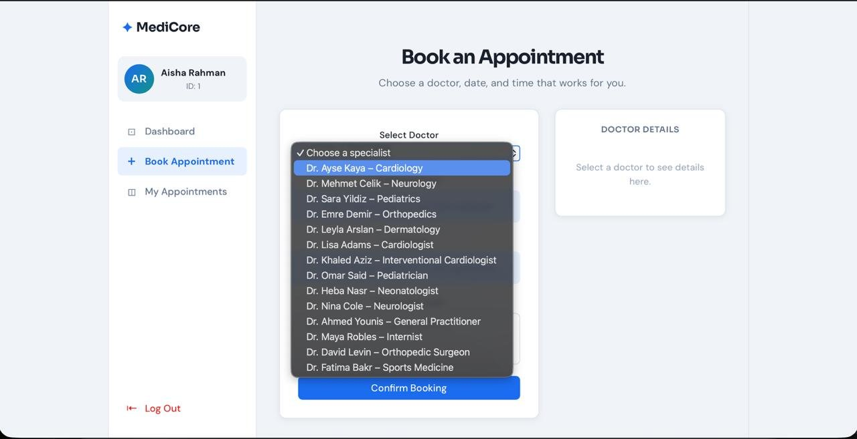
Figure A.1 — Book Appointment: selecting a specialist from the doctor directory (UC-3 → UC-4).
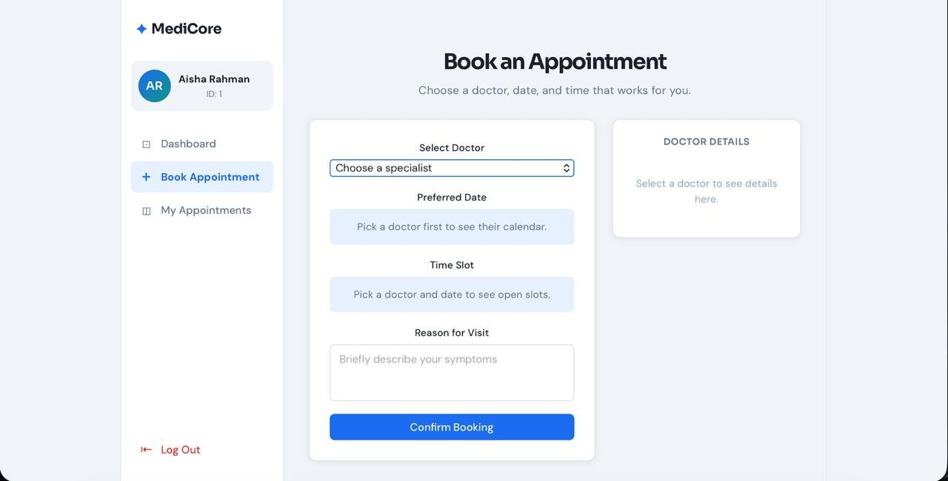
Figure A.2 — Book Appointment: initial state. The calendar and slot grid stay disabled until a doctor is chosen, preventing invalid bookings.

A.2 Doctor Workspace
The doctor role exposes four inline pages, all served from REST endpoints (no redirects to server-rendered templates).
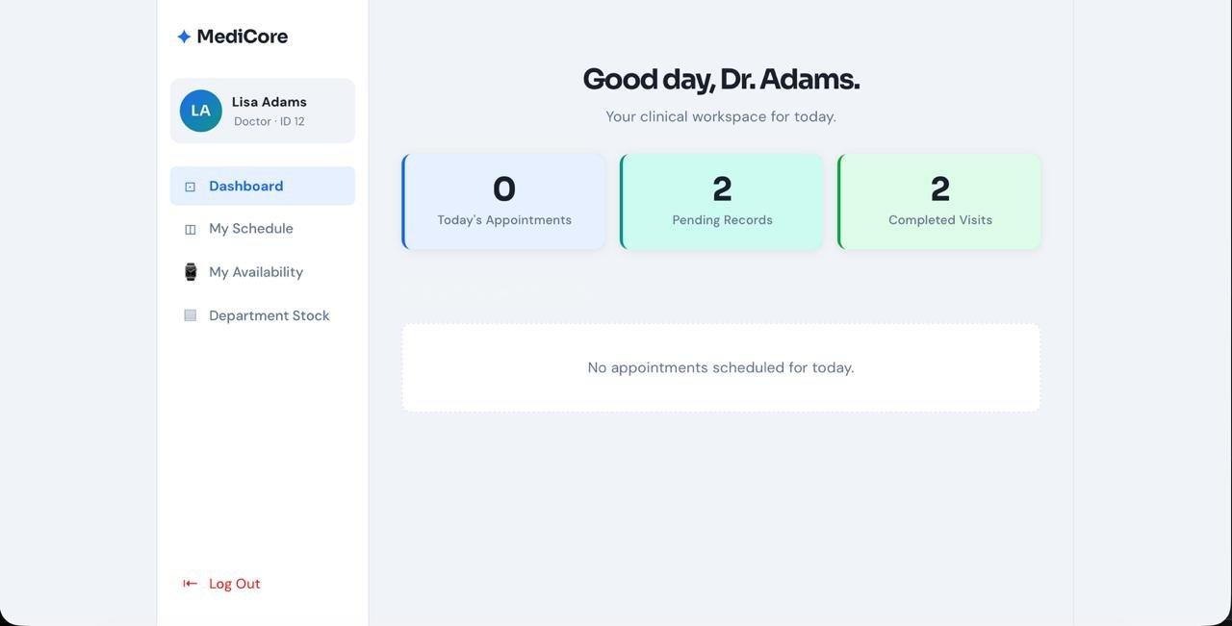
Figure A.3 — Doctor Dashboard. Today's appointments, pending records, and completed visits (UC-6).
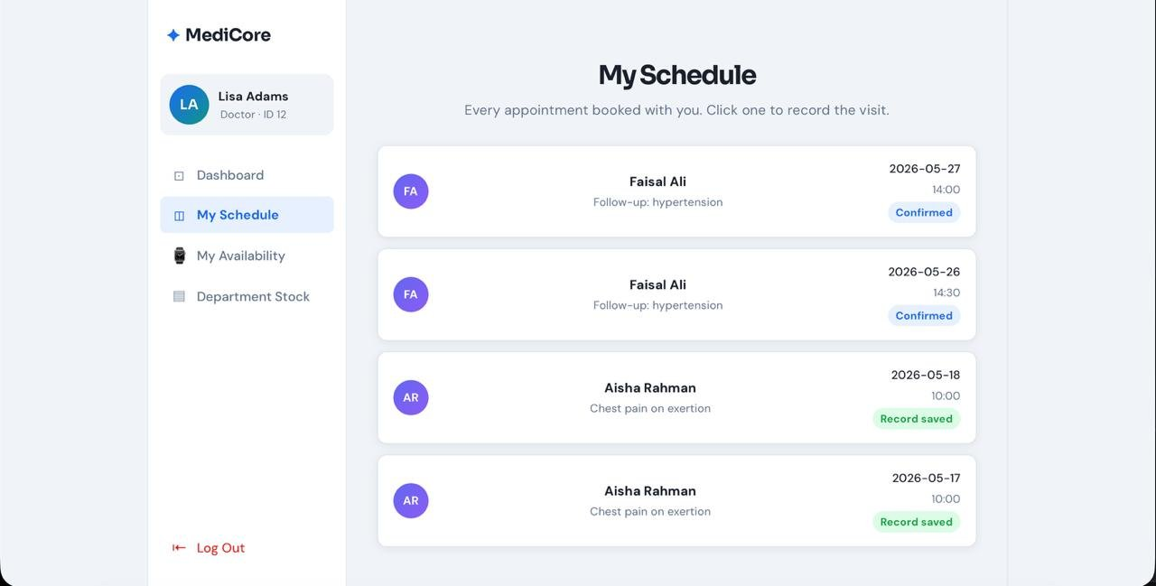
Figure A.4 — My Schedule. Every appointment booked with the doctor; clicking one opens the record/prescription modal. 'Record saved' marks completed visits (UC-7/UC-8 via /api/me/schedule/ and /api/appointments/<id>/record/).
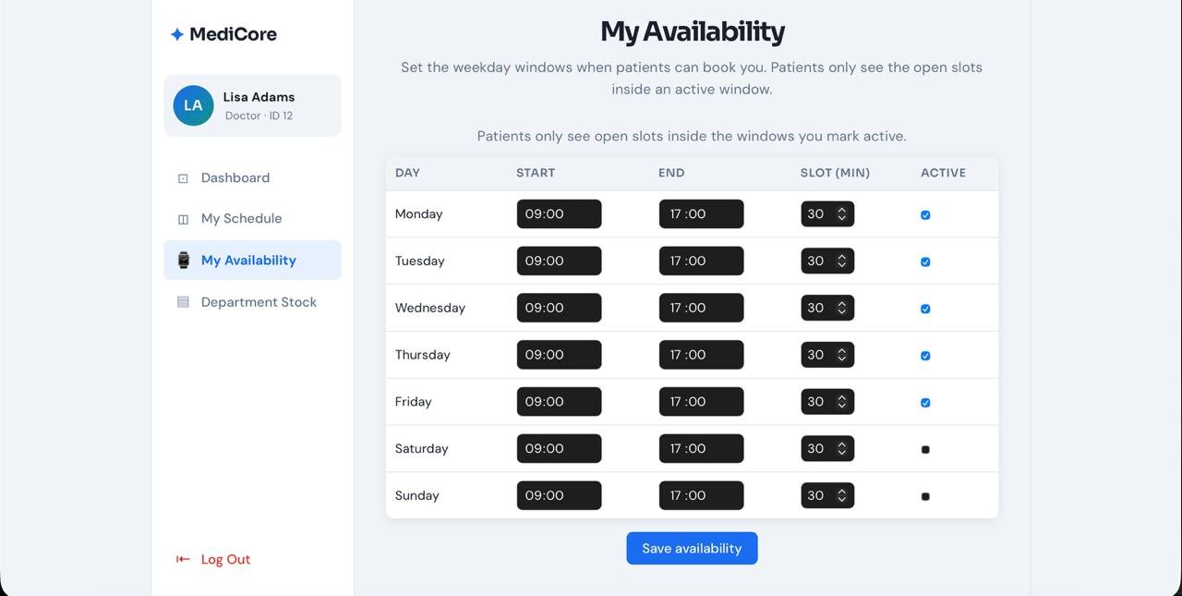
Figure A.5 — My Availability (UC-18). Per-weekday windows with start/end time, slot length, and active toggle; these rows drive the patient booking calendar (§8.4).
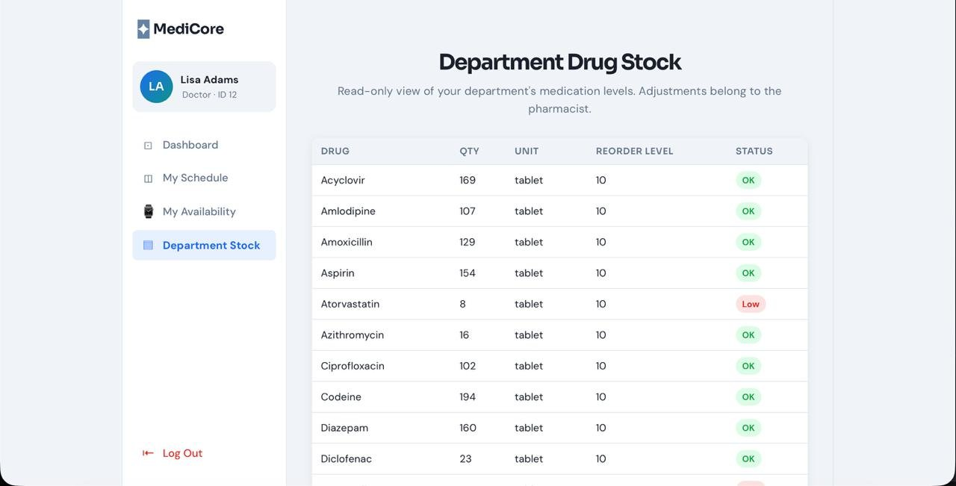
Figure A.6 — Department Drug Stock (UC-12). Read-only, department-scoped; the 'Low' badge flags rows at or below the reorder level (§8.7).

A.3 Nurse Workspace
The nurse role is the system's clearest example of read access without write authority, bounded by department. Every page below is read-only and shows only the nurse's own department (here, Cardiology); a nurse can never write a record, prescribe, or see another department's data.
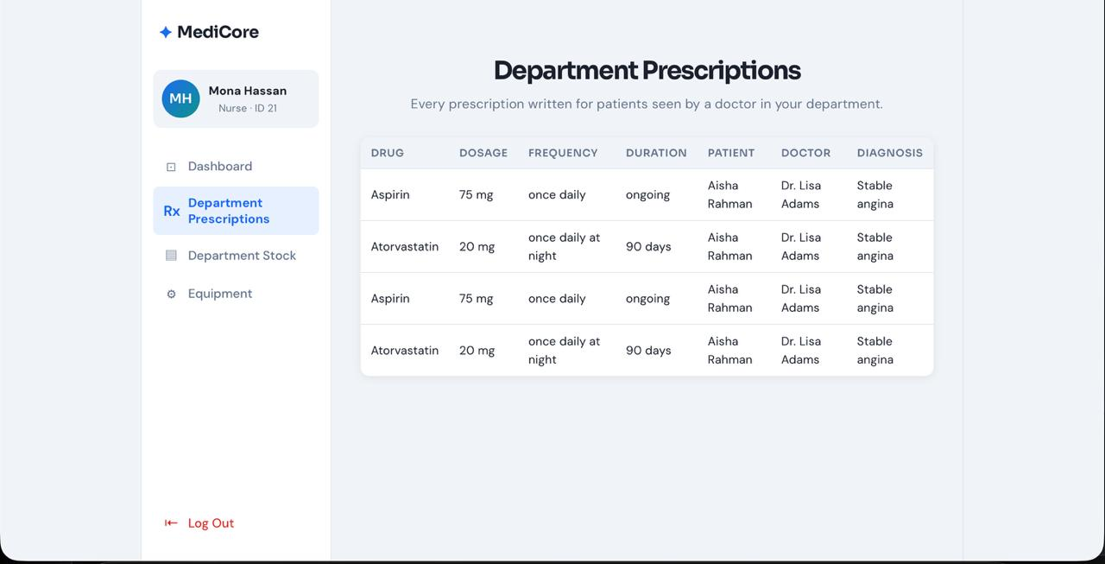
Figure A.7 — Department Prescriptions (UC-9). Every prescription written for patients seen by a doctor in the nurse's department, supporting dispensing. Read-only — nurses dispense, they do not prescribe.
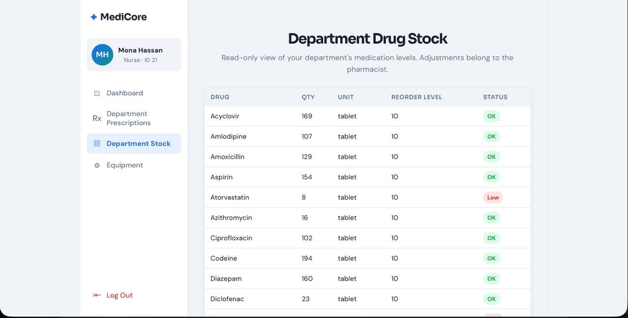
Figure A.8 — Department Drug Stock (UC-12). The same inventory the pharmacist maintains, surfaced read-only to the nurse for dispensing decisions; adjustments belong to the pharmacist.
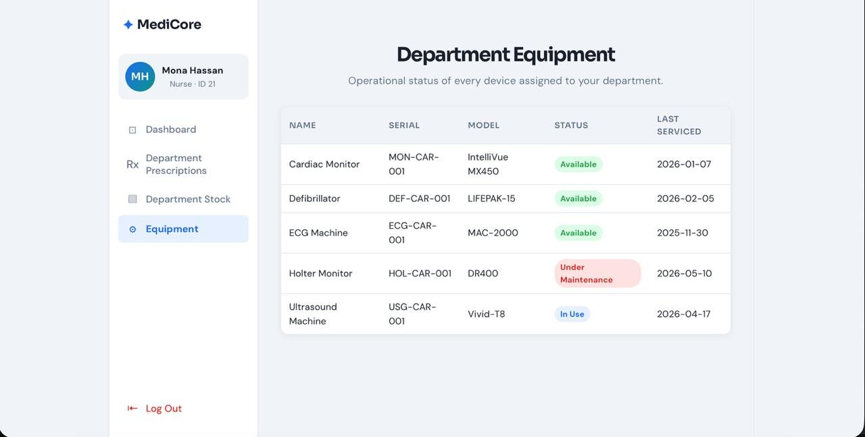
Figure A.9 — Department Equipment (UC-13). Operational status of every device assigned to the nurse's department (Available / In Use / Under Maintenance).

A.4 Administration
The admin dashboard summarizes the system and links to the Django admin for full create/update/delete on every entity.
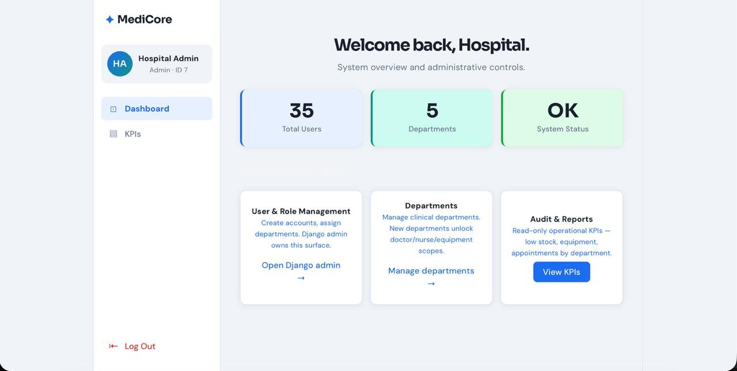
Figure A.10 — Admin Dashboard. System overview (total users, departments, status) with inline KPIs and a link into the Django admin (UC-16).
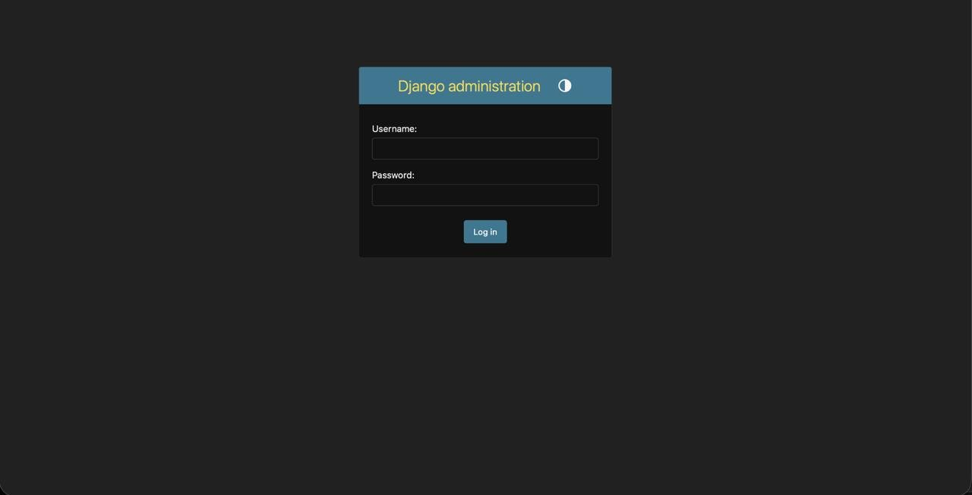
Figure A.11 — Django admin login. The administrative surface authenticates with its own session, separate from the SPA's token.
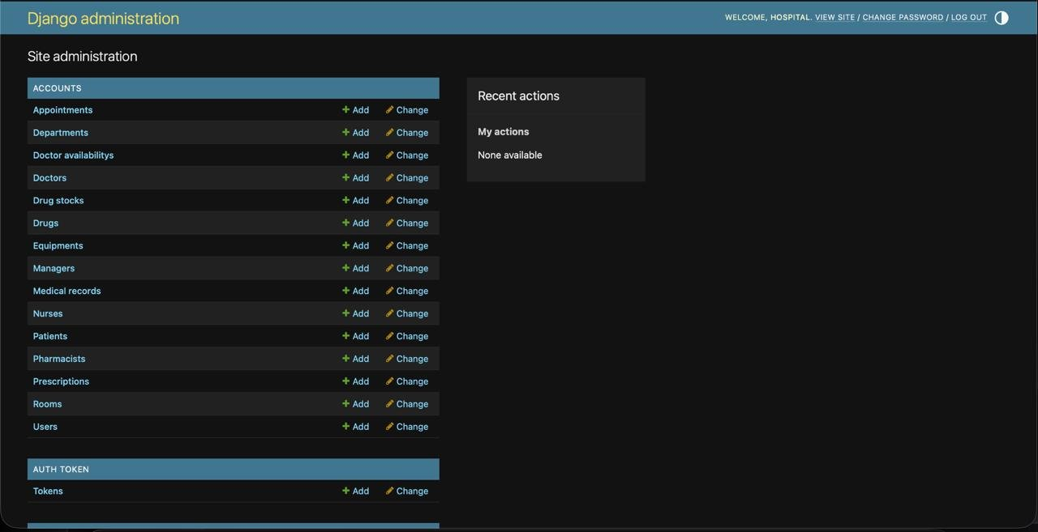
Figure A.12 — Django admin home. Every one of the 15 entities is registered for administrative CRUD.
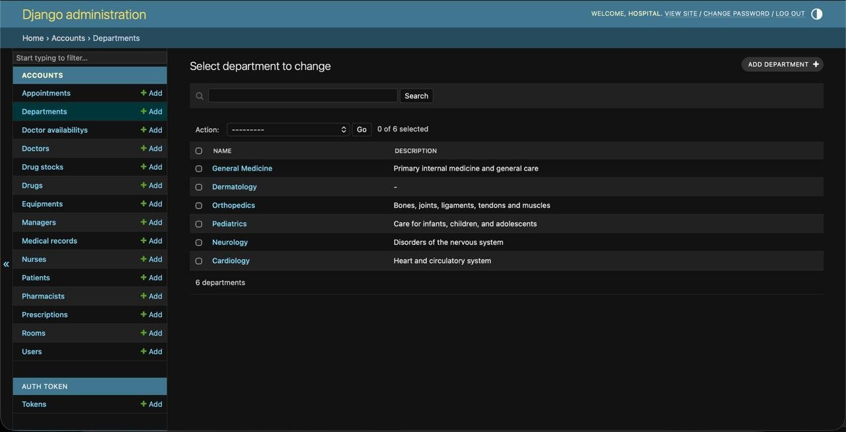
Figure A.13 — Django admin: department management (UC-16). Departments are the scope boundary for doctors, nurses, stock, equipment, and rooms.

Appendix B — Running the System and Accessing Each Role
This appendix is a reproducible guide for running the system locally and signing in as each of the six roles, so the implementation can be verified end-to-end.

B.1 Prerequisites
- Python 3.10–3.13 (3.12 recommended). Python 3.14 may fail to build some dependencies; if so, use 3.12.
- Node.js 20 or newer (for the React frontend build/dev server).
- Git, to clone the repository.

B.2 One-Command Setup
The repository ships an OS-specific setup script that installs dependencies, runs database migrations, seeds every demo account, and starts both servers.
Shell
# macOS / Linux
git clone https://github.com/alrawii2/hospital-managemen-systems-PHASE-2.git
cd hospital-management-system-
chmod +x setup.sh
bash setup.sh

# Windows (Command Prompt or PowerShell)
git clone https://github.com/alrawii2/hospital-managemen-systems-PHASE-2.git
cd hospital-management-system-
.\setup.bat
When setup finishes, the browser opens the application. If the demo accounts are ever missing, re-run the idempotent seed: python manage.py seed_data.

B.3 The Two Login Surfaces
The system has two distinct entry points. Understanding the difference is important when verifying each role.
Surface | URL | Who uses it | Authentication
MediCore SPA | http://localhost:5173 | All six roles sign in here | Token (issued by /api/login/)
Django admin | http://localhost:8000/admin/ | Admin role (user/dept/entity CRUD) | Django session
Health probe | http://localhost:8000/api/health/ | Ops / Docker healthcheck | none
Every role — patient, doctor, nurse, pharmacist, management, and admin — logs in through the same MediCore login screen at port 5173; the backend returns the user's role and the SPA renders the matching dashboard. The Django admin at port 8000 is an additional, separate surface that the admin role uses for full create/update/delete on every entity; it authenticates with its own session and is not part of the SPA token flow.

B.4 Demo Accounts
Every account uses the same password: Pass1234!. Login is by username (not email). Accounts are created by the seed command and listed authoritatively in accounts/management/commands/seed_data.py.
Role | Username(s) | Sign in at | What you can verify
Patient | patient1 … patient15 | MediCore SPA (:5173) | Browse doctors, book via the availability calendar, view and cancel own appointments
Doctor | doctor_cardio, doctor_cardio2, doctor_pediatric, doctor_pediatric2, doctor_neuro, doctor_general, doctor_general2, doctor_ortho, doctor_ortho2 | MediCore SPA (:5173) | Daily schedule, weekly availability, write records and prescriptions, read department stock
Nurse | nurse_cardio, nurse_pediatric, nurse_neuro, nurse_general, nurse_ortho, nurse_oncall | MediCore SPA (:5173) | Read-only, department-scoped: prescriptions, drug stock, equipment
Pharmacist | pharmacist1, pharmacist2 | MediCore SPA (:5173) | Drug catalog and stock (hospital-wide, read/write)
Management | manager1, manager2 | MediCore SPA (:5173) | Operational KPIs: low stock, equipment status, appointment volume (no PHI)
Admin | admin | MediCore SPA (:5173) + Django admin (:8000/admin/) | System overview and KPIs in the SPA; full entity CRUD in the Django admin
Suggested verification order: patient1 → doctor_cardio → nurse_cardio → pharmacist1 → manager1 → admin. One account per role is sufficient to exercise every dashboard; department-scoped roles (doctor, nurse) are best checked with a Cardiology account so the data lines up with the seeded appointments and prescriptions.

B.5 Stopping and Resetting
- Stop the servers with Ctrl+C in each terminal window.
- Reset the database to a clean seeded state: delete the SQLite file (or run python manage.py flush), then python manage.py migrate and python manage.py seed_data.
- Production deployment (Docker Compose: Nginx + Gunicorn + PostgreSQL + Redis) is described in §7 and in deployment/README.md.

